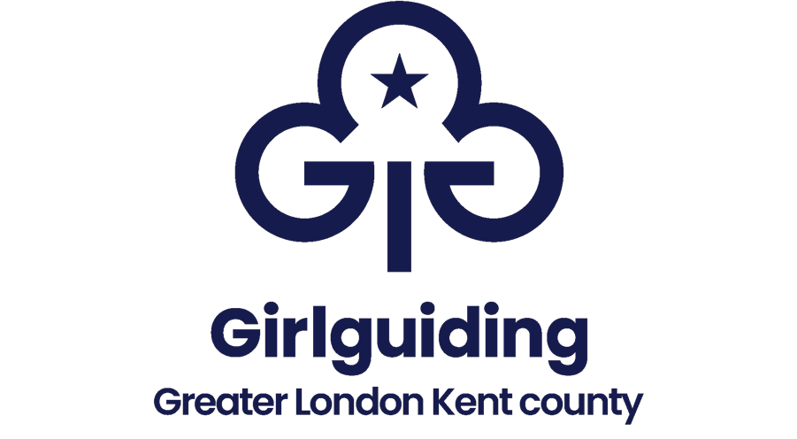

GREATER LONDON KENT – COUNTY AWARDS
NOMINATION FORM

Detail of member and Commissioner recommending this award

NAME OF MEMBER:- Membership number:-

Unit / positions held:-

RECOMMENDING COMMISSIONER

Name:-

District or Division:-

Please attach two supporting letters, which demonstrate their eligibility for an award. Wherever possible the letters should include details of the various roles the nominee has held over the years. If the Awards Committee decide a Region Award should be considered, you will be contacted and asked to supply further supporting letters. Any awards given should recognise their contribution to Girlguiding so please ensure this is covered in the supporting letters.

Recommending Commissioner’s comments:

Nominations for any awards should be confidential and not discussed with the nominee

Please submit applications to:-

guidingglk@yahoo.co.uk

By the end of March and the end of September for consideration by the Awards Committee

