Girlguiding LaSER Goes Further in 2021
International Adventures Leaders Information Evening
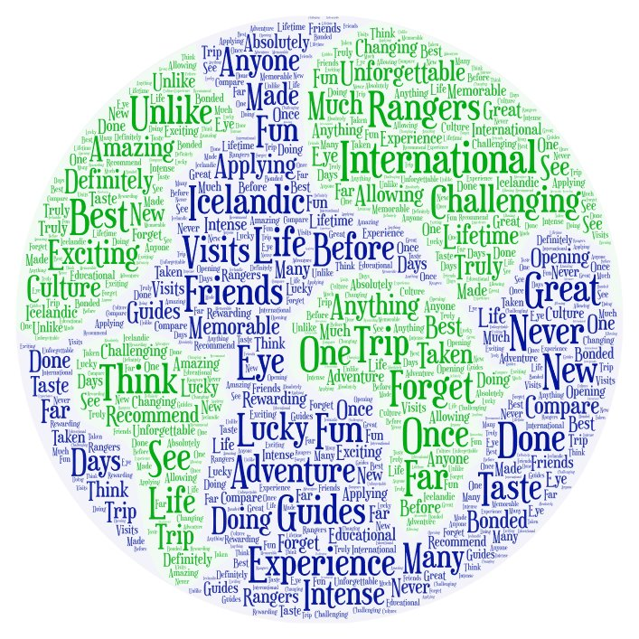
A weekend city break in Europe,
A visit to a world centre,
An international Jamboree,
An adventure expedition,
A service project,
A trip to Disney,
A hosted trip to meet Guides in another country,
An outdoor activity holiday,
An interrailing journey around Europe,

The possibilities are endless…

Are you intrigued?

Would you consider taking your Guides or Rangers out of the country as part of Girlguiding LaSER’s Goes Further Challenge to help celebrate 50 years of LaSER?
We invite you to come along and meet the GLK and Croydon international team to explore how you, and/or your girls, could take part in international adventures in 2021 (and beyond).
The aim of the evening is to help provide inspiration and information about how your girls could join county and region adventures, how you and other leaders could volunteer to lead a District/Division/County group, or how you could take your own unit away.
Come along on your own or with friends to find out more and discuss ideas.
When: 7.30-9pm, Monday 23rd March 2020
Where: Heartsease Guide House, Woodland Way, West Wickham BR4 9LT

To help us prepare please let us know you will be coming by emailing:
- GLK International Advisor – International.glk@gmail.com
- Croydon International Advisor – jill.x.kyne@gmail.com

If you cannot attend but want more information please just contact us on the above email addresses.

