Girlguiding International Opportunities 2021
- Are you a Guide, Young Leader or Ranger who will be aged 13-17 in the summer of 2021?
- Do you like to travel with friends, see new places, meet new people?
- Have you ever helped with planning your own trip?
- Would you like to go on Safari, explore the jungle or be part of a service project helping the local people of another country?
- Could you be a great team member of a Girlguiding international experience in the summer of 2021?
If you answer yes to these questions then come along to find out more at this year’s international opportunities day.
You will spend the day getting to know other people, practicing your teamwork, learning new skills and finding out about what being part of an international trip would be like.
When: Sat 25th April 2020, 9am – 9pm
Where: Cudham Guide campsite, 144 Cudham Lane North, Cudham, Sevenoaks, TN14 7QT
The cost of the day is £5 (which will be payable on the day)
If you are interested in joining us for the day then please complete the attached application form below by Fri 3rd April 2020. We will then send you more information about the day
If you, your parents or leaders, have any questions then please do let us know. You can contact us on GLK International Advisor : International.glk@gmail.com or Croydon International Advisor jill.x.kyne@gmail.com
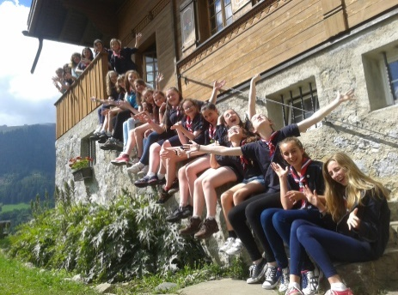
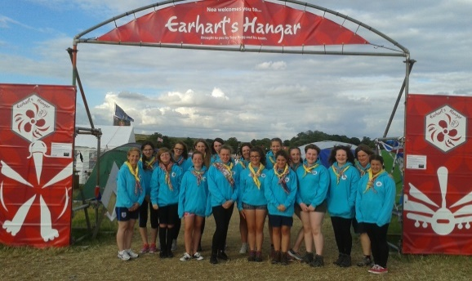
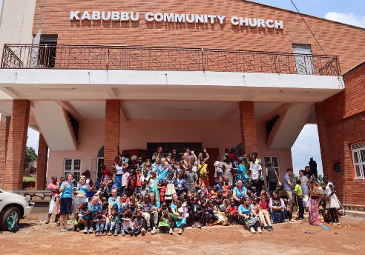

Application form – Participant
International Opportunities 2021
Please complete this form electronically and return by email to either the GLK International Advisor International.glk@gmail.com or Croydon International Advisor jill.x.kyne@gmail.com
PERSONAL DETAILS
Membership no:
Surname:
First names
Address:
Postcode:
Home Phone number:
Your mobile number:
Your email address:
Date of birth:
Parent’s Names:
Parent’s contact number:
Parent’s contact email :
GIRLGUIDING DETAILS (please ask your leader for help if you aren’t sure of some of these)
Current role(s) in Girlguiding:
Your Unit name:
Your District:
Your Division:
YOUR GIRLGUIDING EXPERIENCE
Residential experience – Approx. how many nights have you spent away with Girlguiding and were these camping or indoors:
What are your favourite activities with Girlguiding?
YOUR OTHER EXPERIENCE
What interests/hobbies do you have outside Guiding?
YOUR INTERNATIONAL EXPERIENCE
Which countries have you visited?
Country: |  |  | What year? |  |  | Did you go with Guiding – what kind of trip was it? Was it with your school? Or with family/friends/alone?
Do you speak any other languages and to what level?
Please tell us something about yourself, your family and your local community:
Please tell us why you would like to participate in a Girlguiding International trip?
Do you have any particular needs which we should be made aware to support you? If so, please give details.
Health:
Mobility:
Dietary:
Your Unit Leader contact details
Unit:
Leader’s Name:
Leader’s Tel:
Leader’s Email:
Parent/Guardian’s name and endorsement:
I confirm that I am happy for my daughter/ward to attend the international opportunities weekend and if she is offered an international experience would fully support her application
Signature/ Name: |  |  |  |  |  |  | Date:

