**Girlguiding Greater London Kent**

**50th Birthday Challenge**

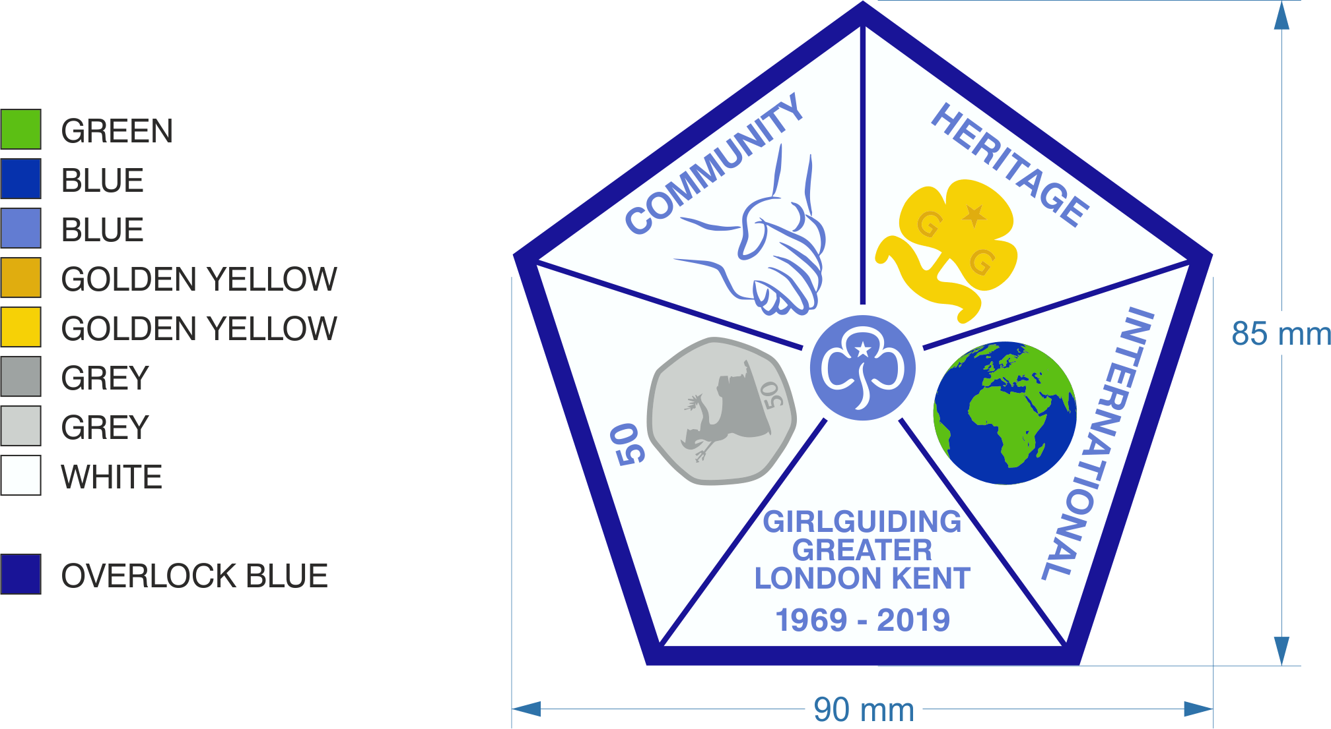

Information for Leaders

**Greater London Kent County**

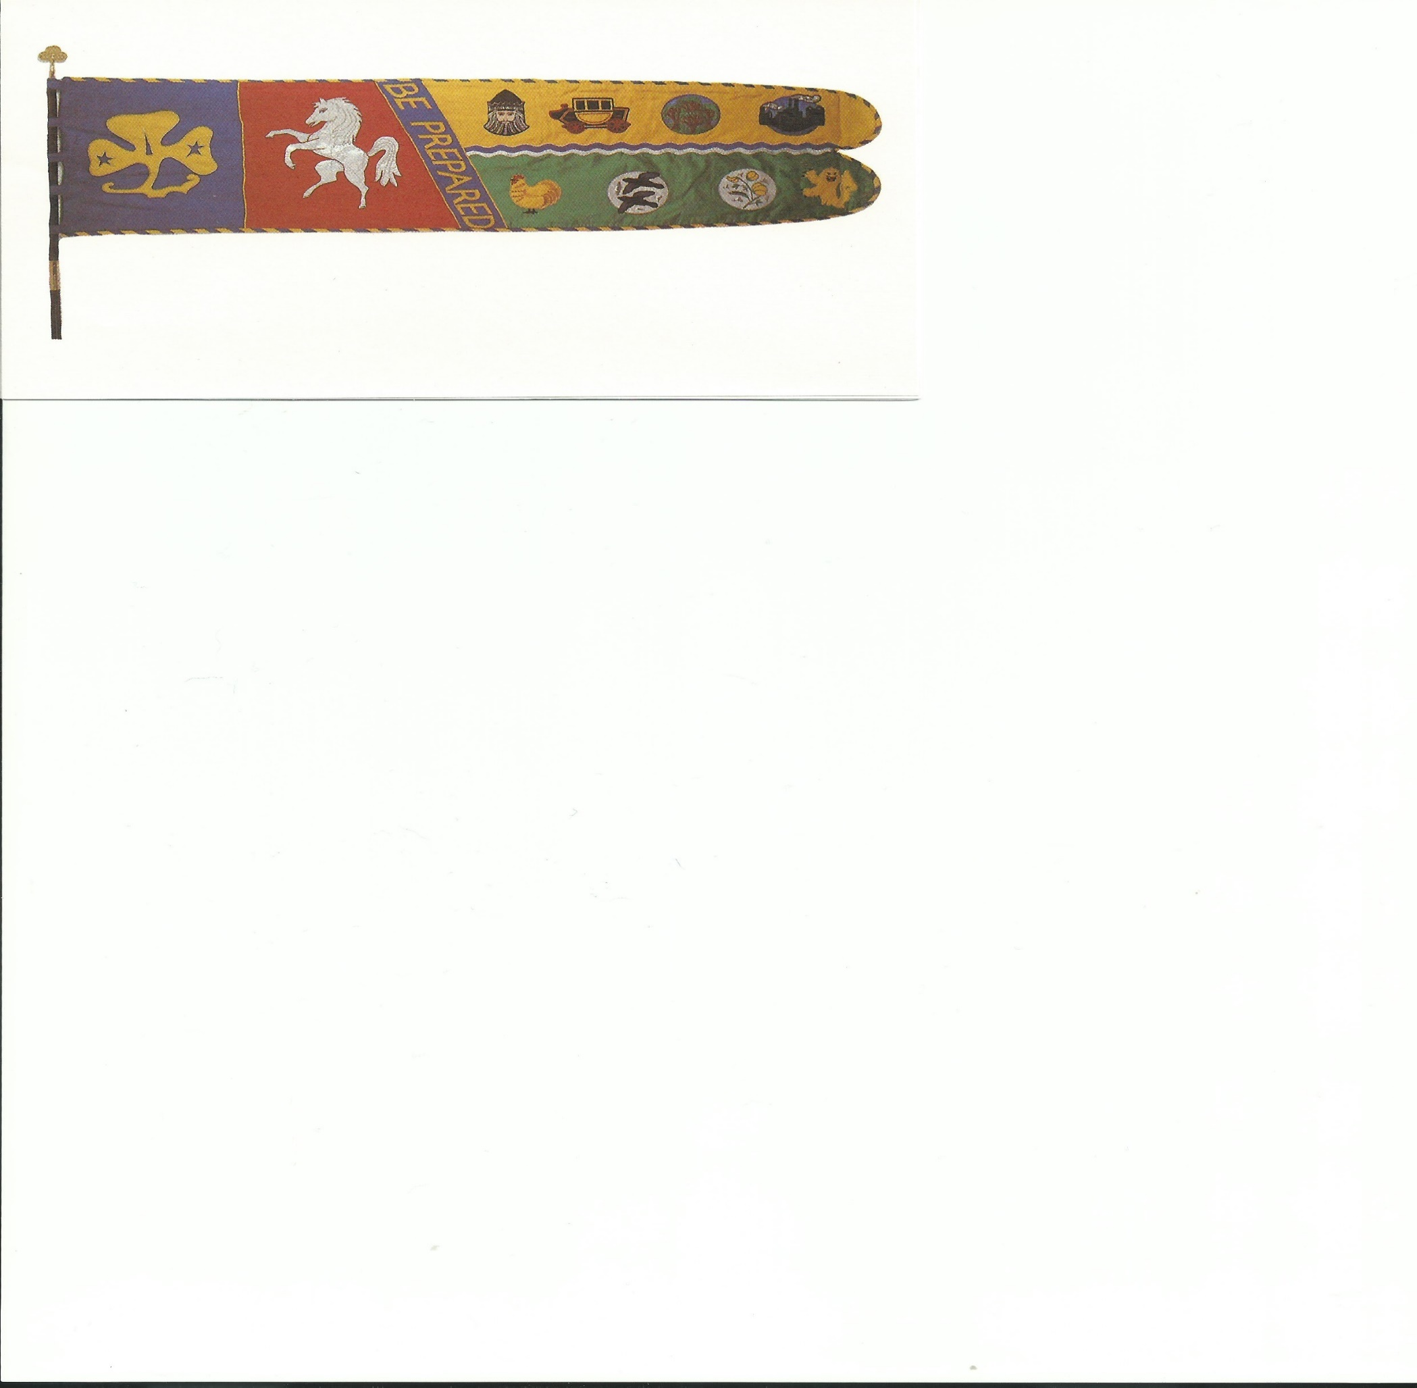

The County was formed in 1969 and the standard was dedicated on 24th June 1974 at Rochester Cathedral.

* The Golden Trefoil represents Guiding throughout the world
* The White Horse of Kent – Invicta means unconquered because the people of Kent refused to submit to William the Conqueror

There are then 8 symbols to represent each of the eight Divisions that make up the County. From left to right starting with the top row these are-

* **Hurst – the Black Prince –** to represent Edward, the Black Prince, is said to haunt Hall Place in Bexley
* **Bexleyheath – a stage coach –** to represent the old Dover Road via Shooters Hill
* **Chislehurst – trees –** to represent Chislehurst Common
* **Erith and Crayford – a factory –** to represent the industrial Thames river side
* **Orpington – a chicken –** a breed of chicken called a Buff Orpington
* **Bromley South – the black ravens –** for the River Ravensbourne that flows through the Division
* **Bromley North – a sprig of broom -** as Bromley was originally known as Broomleigh which stands for where Broom grows
* **Beckenham – the Cator Lion -** there is a gold lion on Beckenham’s coat of arms and it comes from the family crest of the Cator family who were Lords of the Manor in Beckenham in the 1700’s. Cator Park in Beckenham was originally part of the family’s estate.

Green Chain Walk - https://tfl.gov.uk/modes/walking/green-chain-walk

**Community**

GLK is supporting three charities as part of our 50th year and all units are asked to try and raise £50

Information about the three charities is below. The charities were chosen as one that works in Bromley, one in Bexley and RETTS syndrome as that affects predominantly girls

**Bromley JusB**

JusB is a community-based youth centre that works with young people during their journey to independence, helping them to make the most of their potential. Over the last ten years they have worked with thousands of young people through various projects. Their vision ‘A Brighter future for young people in Bromley’ is very relevant in today’s environment, as many young people and families struggle to cope in difficult times.

**Bexley Young Carers**

Being a Young Carer can have a negative impact on a young person such as low confidence and self-esteem, low educational attendance and attainment and poor physical and mental health.  It is Bexley Young Carers aim to reduce the negative and highlight the positive impact of being a carer such as increased resilience, empathy, non-judgmental attitude and caring nature.

Bexley Young Carers delivers a support service to anyone aged 8-18 living in Bexley who is taking on caring responsibilities for a family member with a long-term illness, disability, mental health or substance misuse issue. They enable young carers to receive some respite from their caring responsibilities, socialise with their peers and receive tailored support and information

**Rett Syndrome Charity**

Rett Syndrome is a neurological and developmental disorder which affects female patients nearly exclusively. The symptoms of this syndrome vary from person to person. However, there are some tell-tale signs that most doctors in the UK recognise almost immediately. They include slowed physical development, such as slowed head and brain growth in girls. It is also characterised by an inability to properly use one's hands, as well as problems walking. Intellectual disabilities occur as a result, and many people who have Rett Syndrome, also suffer from seizures.

Collect items for your local food bank:-

Bromley - <https://bromleyborough.foodbank.org.uk/>

Bexley - <https://bexley.foodbank.org.uk/>

**Heritage**

Do an interest badge from 50 years ago

* Ask previous leaders / maybe Trefoiil members if they have copies of old badge books
* <http://guiding.mostlyharmless.org.uk/old-guide-badges/> has some old Brownie and Guide badge syllabuses

How to pitch a ridge tent:-

1. Select a suitable site for your tent; it should be as flat as possible. Remove any pebbles, stones and anything else you wouldn't want to sleep on!

2. Unpack the tent from its bag carefully; check that dollies / main guys, all poles, pegs & mallets are present.

3. Assemble the ridge pole and place it exactly where you want the centre line of your tent to be.

4. Knock in a brailing peg at each end of the ridge pole.

5. Now assemble the upright poles; you will need these to measure out where to put the pegs for the main guys.

6. Stand at one end of the ridge pole, facing outwards from where the tent will be. Put your feet with the heels touching the brailing peg, one in line with the ridge pole and the other at right angles to it.

7. Hold one upright pole with its end in between your feet, as close to the ridge pole as you can get it. Lower it carefully onto the ground so that it cuts the angle made by your feet in half. Knock a large peg into the ground at the far end of the pole, ready for one of the main guys.

8. Repeat this process another three times, once more at the same end of the tent as the peg you have just knocked in but placing your feet facing towards the other corner, and twice at the far end of the tent. Your pegs should mark out a large rectangle if you have measured correctly.

9. Remove the poles and put them to one side where you can reach them easily - you will soon need them again. Unfold the tent canvas and spread it out (with the doors still laced) roughly where your tent is to be pitched; the ridge of the tent should be parallel with the brailing pegs already in and the bottom of the doors roughly at the brailing pegs.

10. Carefully put the ridge pole in place inside the canvas (depending on your tent, you may have to take it apart again.) DO NOT STAND ON ANY PART OF THE CANVAS.

11. Insert the upright poles with the tent still on the ground and put the dollies and main guys on the spikes at the ends.

12. Unfasten the main guys, run the sliders down and drop one guy loosely over each of the four main pegs, with a Guide in attendance at each one.

13. Now get ready to lift the tent : you will need all the help you can rally! One Guide needs to be at each of the end poles and at least one at each end of the tent to see to the main guys. At a given signal, lift the tent steadily, with hands well apart on the uprights and keeping the ridge pole straight - if you have anyone tall enough to reach, enlist their help to steady the ridge pole too. (If your tent has a centre pole, you will need someone inside the tent to lift that also - she must take care not to stand or kneel on the canvas.) As the tent rises, someone will have to adjust the main guys to allow it to rise evenly and with all the poles straight. Make sure you keep the bottom ends of the uprights against the brailing pegs put in earlier.

14. Once your tent is up, tighten the main guys to hold it up straight - if you have done everything correctly, your tent will stand with just these four guys. (Make sure the guys are not tangled or twisted round the dollies.)

15. Make sure the doors are laced - if they have come apart, re-lace them. Loop the ends of the door laces over the brailing peg previously placed at the foot of the poles. Hold out the front corners and the roof corners of the tent and peg out the bottom corners with brailing pegs so that your tent is a perfect rectangle: the canvas should hang smooth and wrinkle - free whilst you are still holding the corners of the roof out. Do not put the guys over the pegs until the pegs are in place - NEVER hammer any peg whilst the guy is over it.

16. Now unfasten the side guys. Peg out the guys for the front corners first - choose the angles which make the tent hang neatest. Stand with your back to the tent when you knock the pegs in; the pegs should be placed so that the guys follow the line of the slope of the roof.

17. Peg out the side guys, keeping the pegs in line and equally spaced. Keep checking that your tent is still hanging square - don't be tempted to over-tighten the guys.

18. Put in brailing pegs around the bottom of the tent walls. (Brailing pegs go in vertically - all other pegs at an angle sloping away from the tent.) Loop the brailings over the pegs - some loops will require twisting to keep them in place.

19. Stand back and inspect your tent : is it up straight? Is the canvas reasonably taut? Are the guys and pegs evenly spaced and in straight lines? Open the door - are the posts still vertical and in line? If anything needs adjusting, do it now! If you want to storm lash your tent, this is the best time to do it :

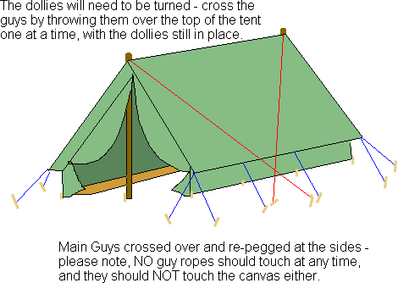

20. Now you can move all your belongings into your Patrol Tent and start making gadgets!

Find out about uniforms that were worn 50 years ago

* Some information about uniforms can be found on <https://lesliesguidinghistory.webs.com/>
* Go to google images and search for vintage Guide / Brownie uniforms
* Ask if any fellow leaders have copies of the uniform charts which were available to purchase some years ago

Find out about some of the traditions of Guiding – using toadstools in Brownies, songs that used to be sung

* Ask some Trefoiil members along to your unit meeting
* <https://lesliesguidinghistory.webs.com/>

**International**

Find out about the World Centres

* Links to the websites of the individual world centres can be found on the WAGGGS website - <https://www.wagggs.org/en/>

**50 Challenges**

Penny Hike – in a group go for a walk from your meeting place. At each road junction toss a coin to determine what way you go next. Heads – left or straight on and Tails – right or straight on