GLK International Opportunities 2020
- Are you a Guide, Young Leader or Ranger who will be aged 13-17 in the summer of 2020?
- Do you like to travel with friends, see new places, meet new people?
- Have you ever helped with planning your own trip?
- Would you be interested in being part of a Girlguiding international experience in the summer of 2020? (this year’s girls will be going to Iceland, Argentina, Uganda and Zanzibar)
- If you answer yes to these questions then you could consider applying to attend the GLK international selection event to take part in trip in 2020.
The trips for 2020 have yet to be decided but it is likely to be an international camp in Europe for week or more and there will also be places for a longer service project with our Region LaSER (London and South East England) expeditions.
If you are interested in applying then please complete the application form below and return it by email to Fie Rason, GLK International Adviser on international.glk@gmail.com by Fri 22nd March 2019. If you, your parents or leaders, have any questions then please do let us know.
You will then be invited to an international opportunities selection weekend at Cudham on 27th -28th April 2019.
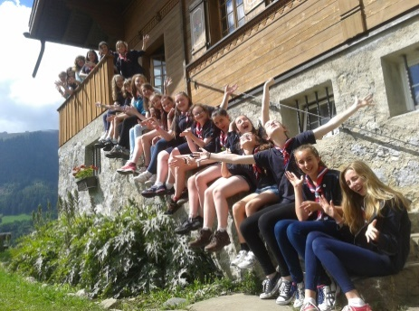
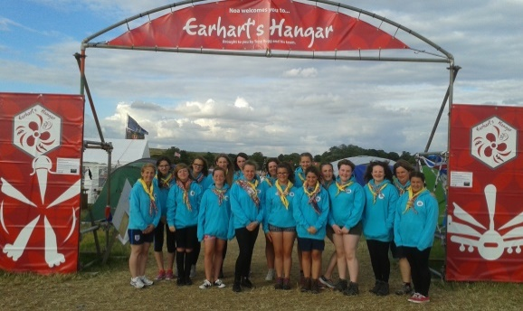
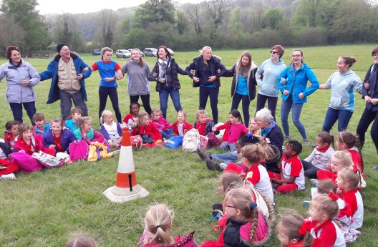

Application form – Participant
GLK International Opportunities 2019 20
Please complete this form electronically and returned the completed form to the GLK International Adviser by email to International.glk@gmail.com by Fri 22nd March 2019
PERSONAL DETAILS
Membership no:
Surname:
First names (in full):
Your preferred name:
Address:
Postcode:
Home Phone number:
Your mobile number:
Your email address:
Date of birth:
Nationality:
Parent’s Names:
Parent’s contact number:
Parent’s contact email :
GIRLGUIDING CAREER (please ask your leader for help if you aren’t sure of some of these)
Current role(s) in Girlguiding:
Your Unit name:
Second Unit name (if applicable):
Your District:
Your Division:
YOUR GIRLGUIDING EXPERIENCE
Residential experience – Approx. how many nights have you spent away with Girlguiding and were these camping or indoors:
What are your favourite activities with Girlguiding?
Have you been involved in any service projects?
YOUR OTHER EXPERIENCE
If you are a student what school/college do you attend?
If you are employed, what is your occupation?
Please list any qualifications you have.
What interests/hobbies do you have outside Guiding?
Do you hold any positions of responsibility outside Guiding?
YOUR INTERNATIONAL EXPERIENCE
Which countries have you visited?
Country: |  |  | What year? |  |  | Did you go with Guiding – what kind of trip was it? Was it with your school? Or with family/friends/alone?
Do you speak any other languages and to what level?
Please tell us something about yourself, your family and your local community:
Please tell us why you would like to participate in a Girlguiding International trip?
Do you have any particular needs which we should be made aware to support you when planning the selection weekend or trips? If so, please give details.
(Any health conditions which may affect the trip insurance MUST be declared at this stage)
Health:
Mobility:
Dietary:
Your Unit Leader contact details
Unit:
Leader’s Name:
Leader’s Tel:
Leader’s Email:
I would like to be considered for a GLK Girlguiding International opportunity.
I confirm that the information on the application is accurate and a true record of my experience.
I also confirm that I have told my Unit leaders of my intention to apply for this opportunity
Signature/ Name: |  |  |  |  |  |  | Date:
Parent/Guardian’s name and endorsement:
I confirm that I am happy for my daughter/ward to apply for an international experience and fully support her application
Signature/ Name: |  |  |  |  |  |  | Date:

