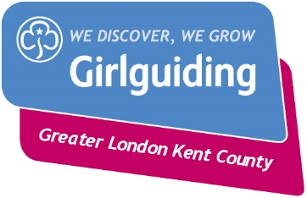
Lord Mayor’s Show Challenge
Badge Order Form

Contact Name
Unit Name
Contact Telephone number
Contact email address

Please contact guidingglk@yahoo.co.uk for more information regarding how to apply for badges.

Total (£)
Number of badges required @ £1.00 per badge

Postage and packaging if appropriate
1-3 badges £1.00
4-10 badges 10 £1.50
11-50 £3.00
Total

Please make cheques payable to: Greater London Kent County Guides

Any questions please email guidingglk@yahoo.co.uk

