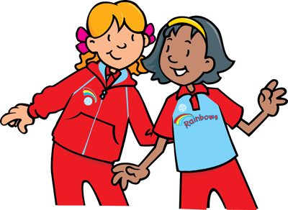
RAINBOW CORNER

This issue of Rainbow Corner looks at Growing Guiding

If your unit is low on numbers why not try:
- Bring a friend night (girls to bring a non-guiding friend)
- Run a competition with a prize for the girl who manages to recruit most new members
- Buy one get one free – or some form of discount (maybe for a term) on unit subs for a girl who introduces a new member
- Develop a partnership with local schools or community organisations
- Talk at a school assembly or after school club
- Leaflets in school book bags
- Door to door leaflet drop
- Display recruitment posters in all meeting places
- Advert in your local paper/community newsletter
- Encouraging units which are full to promote alternative options to enquirers/girls on waiting-to-join lists

Remember that the recommended ratios for meetings are only recommendations. There is no maximum size to a unit so long as the space is big enough and there are enough adults to keep the girls safe. Two adults must be present at Rainbow meetings and ratios become mandatory when away from the meeting place.

Mouse in the House
All of the Rainbows line up at one end of the room with the Leader at the other end. All of the girls march up to the Leader saying:“I’m a big brave mouse and I'm marching through the house and I'm not afraid of anything”
The Leader then says “Not even a ...........” and chooses something that the mouse might be afraid of e.g. dog, cat etc
The Rainbows must then run back to the other end of the hall while the Leader chases them. Any Rainbow caught is out and must then help the Leader to catch the other Rainbows in the next round

Play Blindfold Lego...
One girl is blindfolded and her partner describes to her how to build an object from Lego. All you need is a large box of Lego and a flat surface to work on. Once the first girl has completed her task, they swap roles and she gives the instructions.

Friendship Sticks
Friendship Sticks - make two and give one away to your best friend or a make a new friend and give it to her...
You need two bamboo canes of similar size 30 – 40 cm long. These can then be decorated with ribbon wrapped round, bead strings, coloured string and bows, buttons on wool and tied with pretty knots etc. The object is to decorate the sticks until the girls decide that they are ready to swap with each other.
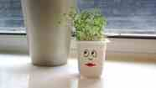
Grow a Girl
Materials Needed:-
An empty, clean yoghurt pot
Kitchen roll
Pens
Cress seeds
Cotton wool
To Make: -
Paint or colour the yoghurt pot and draw on a face. Place some wet kitchen roll in the bottom and put some damp cotton wool on top of the Kitchen roll. Evenly spread some cress seeds on top of the cotton wool and press them down gently (you can add some food colouring to the cotton wool if you want the cress ‘hair’ to be a different colour). Put the pot in a warm place that gets some sunlight like a windowsill and watch the cress grow! This should happen after about 7 days.

Button Bracelets
Materials needed:-
Buttons
Pipe cleaners
To Make: -
Weave buttons onto a pipe cleaner and twist to secure.
Rainbows should make an extra bracelet for a friend in order to show what fun they have at Rainbows.

Why not share your ideas in GLK News with other Rainbow Leaders email any ideas to Debbie at deb69milton@yahoo.co.uk

Debbie Goddard
Rainbow Advisor

