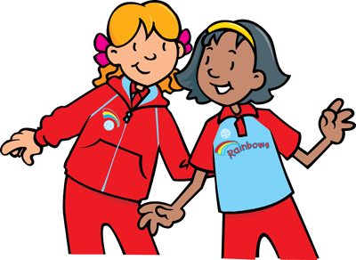
RAINBOW CORNER

This issue of Rainbow Corner concentrates on the Out Doors with ideas that could be used to complete the Greater London Kent Rainbows Out and About Challenge which contains ideas and activities to do with your unit to explore town or country.

Daisy Chain
Can the girls make a daisy chain and then play this game

Sung to the tune of: Mulberry Bush
We can make a daisy chain,
A daisy chain, a daisy chain,
We can make a daisy chain,
A daisy chain for you.

Actions :
1. Girls sit spaced out on the floor.
2. A Leader walks in and out, around the girls, while everyone sings the song.
3. At the end of the song, she holds hands with the girl she is closest with, who stands up to join her in a “daisy chain.”
4. Repeat until you have a long daisy chain, each time adding a new girl to the end of the chain

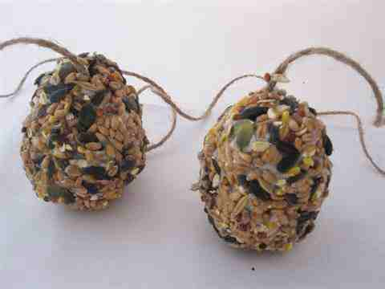
Make Bird Feeders
Make a simple bird feeder by rolling pinecones covered with peanut butter (check health forms for allergies) in birdseed. Tie a piece of wool/string around the top of the pinecone send home with the girls (in a plastic bag) and ask them to hang in garden if nowhere at meeting place. Give the girls a sheet of likely bird visitors and get them to record those seen feeding.

Star Light Star Bright
Star light, Star bright
First star I see tonight
I wish I may, I wish I might
Have the wish I wish tonight.
Then ask the Rainbows to each make a wish!

Sing or recite this after looking at stars in the sky on a dark night

Scavenger Hunt
Instead of collecting the items, record and describe each object as it is found. Do this either as a group or in pairs including an adult to assist with recording.
largest thing something soft
smallest thing something straight
something yellow something that makes noise
coolest place something that can break
oldest thing something that can bend
prettiest thing something out of place
something round something red

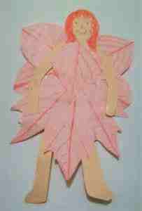
LEAF RUBBING FAIRY
You will need:
Crayons
Paper

Skin tone/white card
Fallen Leaves
Glue
Pens
Scissors

Put leaves under the paper with the veins pointing upwards, holding them still, rub over the paper with the side of a crayon, until a picture of the leaves appears on the paper. Cut out the leaves. Cut out a body shape from the card and draw on a face and some hair. Use the cut-out leaf rubbings to make a dress and wings and glue them to the body.

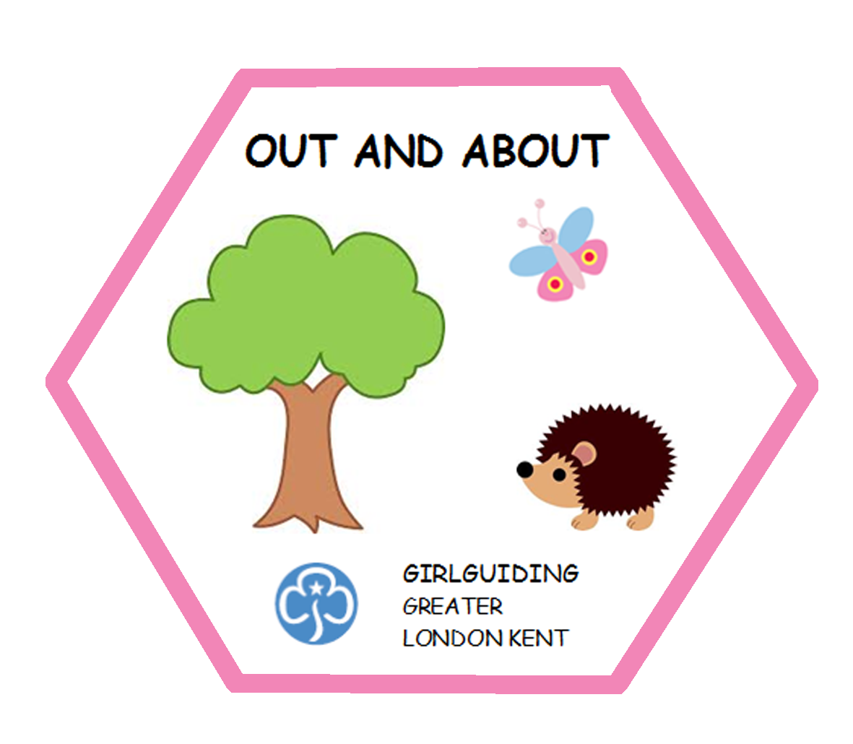

Why not share your ideas in GLK News with other Rainbow Leaders email any ideas to Debbie at deb69milton@yahoo.co.uk

Debbie Goddard
Rainbow Advisor

