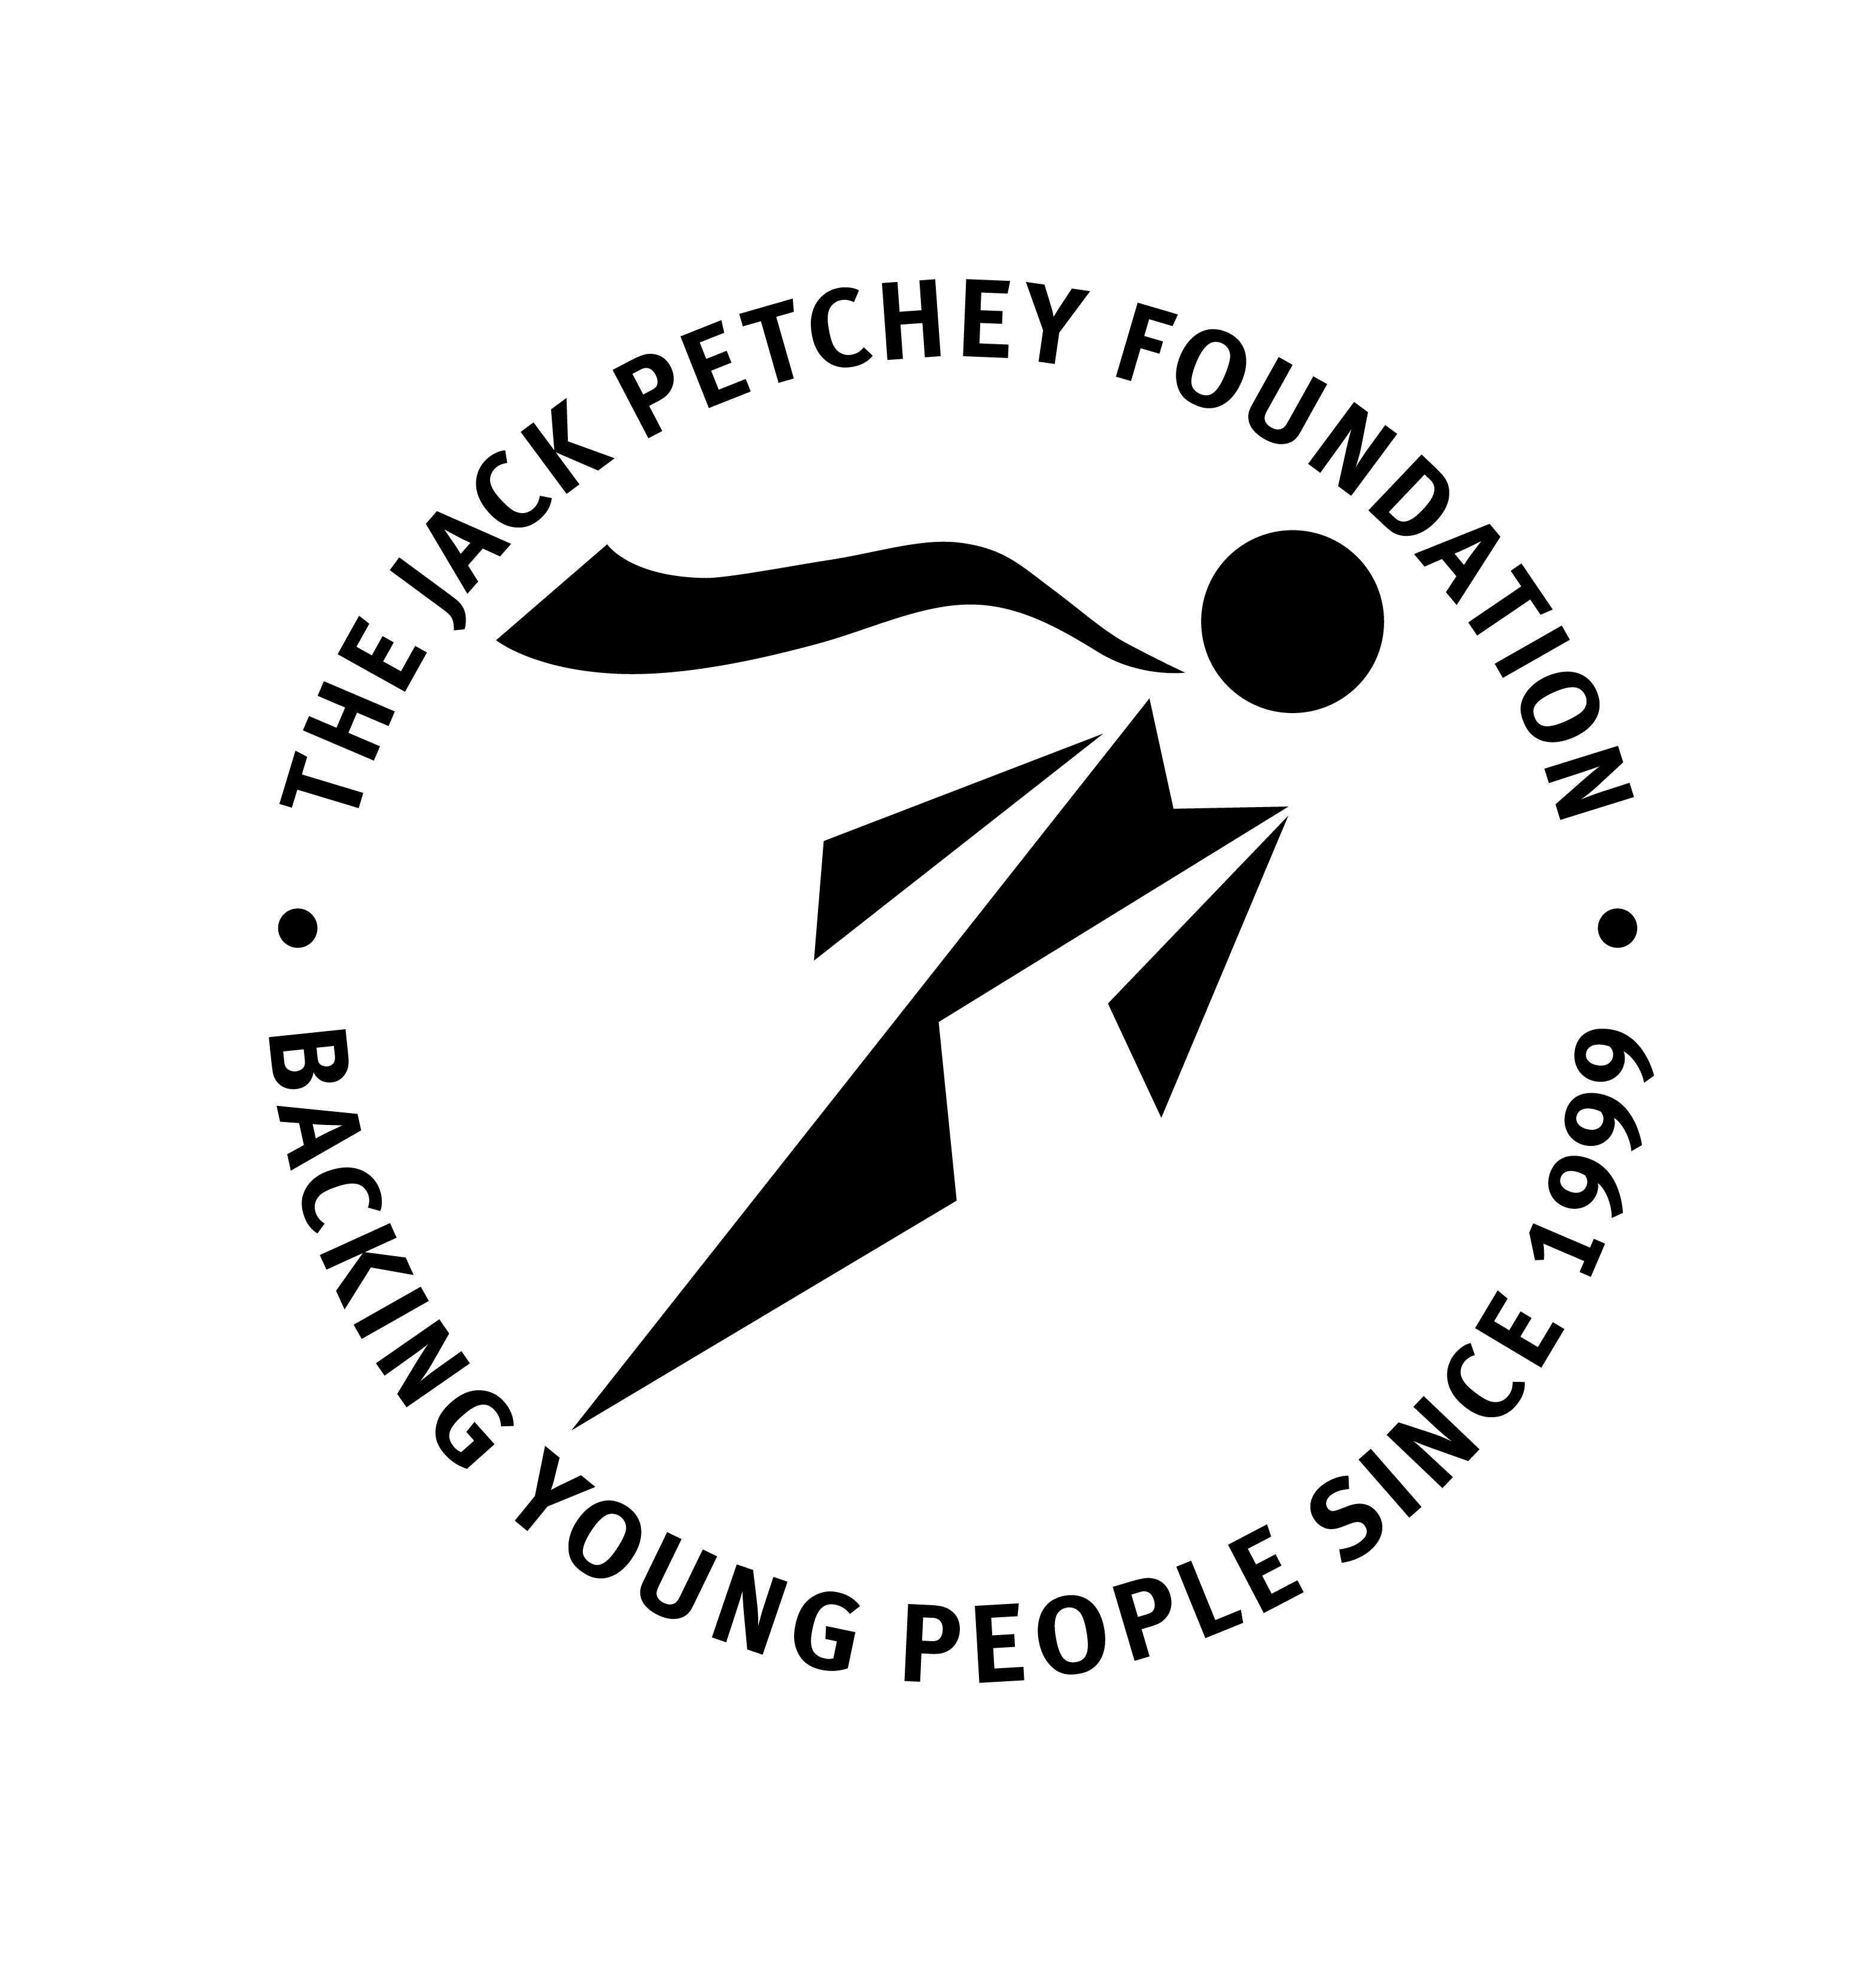

Introduction:

We understand that sometimes young people and youth organisations want to recognise the efforts of those who support them. The Jack Petchey Leader Awards are designed to do just that. Linked to the Jack Petchey Achievement Award Scheme they enable organisations to publicly honour the dedication and commitment of staff and volunteers – particularly recognising those ‘who go the extra mile’ to support young people.

Any organisation participating in the Achievement Award Scheme for over a year can nominate a "Leader" to whom they would wish to give public recognition. Awards are given to adults who have demonstrated, in an outstanding way, an ability to encourage and motivate young people aged 11-25 in London or Essex.

Leader Award Winners must be over 21 years of age and been involved with the organisation for at least 2 years.

If successful they will receive:

- A framed certificate
- A boxed medallion

Please complete this form and pass it to your own Award Scheme co-ordinator to make your nomination (DO NOT SEND THIS FORM TO THE JACK PETCHEY FOUNDATION).

I nominate
I am a  (delete as appropriate) |  | Club Member/ Volunteer/ Parent/ Staff Member/ Other
Reason for Nomination
Name |  |  | Signature |  | Date
If you wish to obtain the support of others
Name |  |  | Signature |  | Date
Name |  |  | Signature |  | Date
Name |  |  | Signature |  | Date

To be placed in the Jack Petchey Achievement Award Nomination Box

